# Systematic Review Methodology (SBDART)

To review the state of the art of aerosol direct radiative forcing studies in urban/rural areas, we start by structuring the systematic review methodology in a step-by-step process following explained.

## Step 1: Scoping

Formulate the Research Question: "How does the SBDART model assess the impact of aerosols on direct radiative forcing in urban/rural environments?"

Now, to narrow down the review to include only studies that use SBDART model to analyze aerosol radiative effects, with a specific focus on urban/rural settings and potentially incorporating lidar data.

## Step 2: Planning

To break down the research question into a key concepts to create comprehensive search terms we define that the following terms are key point to accomplish a fine review:

* SBDART.
* Aerosol radiative forcing.
* Radiative transfer.
* Urban pollution.
* Lidar.

To establishing inclusion and exclusion criteria the preliminary inclusion criteria were:

Inclusion:

* Peer-reviewed papers.
* Direct aerosol radiative forcing studies.
* Estimations performed in urban areas, focusing on valley zones.
* Report of changes in aerosol radiative forcing by comparing with aerosol physical – optical properties.
* Time frame: 2014 – 2024.

Exclusion:

* Book chapters.
* Systematic Reviews.
* SBDART model not included in articles.

It is important to make clear that reviewed papers are searched in EAFIT databases and free access databases like (ScienceDirect, IEEEXplore, SpringerLink, Copernicus, MDPI).

In order to transform the research question into key concepts, in ScienceDirect the search equations were “SBDART”, “SBDART radiative transfer”, “SBDART aerosol radiative forcing”, “SBDART urban pollution” and “SBDART lidar”. From this initial search taking consider of the time frame previously defined, the total results were 268, 253, 201, 112 and 85, respectively.

## Step 4: Screening

Initial Screening: Screen titles and abstracts to exclude studies that do not meet the inclusion criteria.

Secondary Screening: Examine full texts of the remaining studies to confirm their relevance to the research question.

After initial and secondary screening, 47 papers were selected to be reviewed in step 5.

## Step 5: Eligibility

Final Selection: From the screened studies, select those that specifically address the impacts of aerosol direct radiative forcing using the SBDART model, and ensure they are methodologically sound and relevant.

In final selection, 23 out of 47 papers turn out to be useful since they apport in the methodological procedure that allow to carry the research question on.

## Step 6: Synthesis

Data Extraction and Analysis: Extract data from the selected studies, focusing on key variables like aerosol properties, radiative effects, and the utilization of lidar data.

Synthesize Findings: Summarize and synthesize the findings to answer your research question, discussing how the SBDART model contributes to understanding aerosol impacts in urban/rural settings.

## Step 7: Writing the Review

Draft the Review: Organize the information systematically, providing a background of the SBDART model, methodologies used in the studies, key findings, gaps in the research, and implications for future studies.

Peer Review and Revision: Submit your review for peer feedback and revise accordingly to ensure accuracy and comprehensiveness.

## Appendix:

Analysis and review of determinant information extracted from individual papers.

#### Aerosol direct radiative forcing in desert and semi-desert regions of northwestern China.

DOI: 10.1016/j.atmosres.2015.12.004

Presents the formula to estimate the aerosol´s effect on the radiative fluxes in 4 different locations using the following equation.

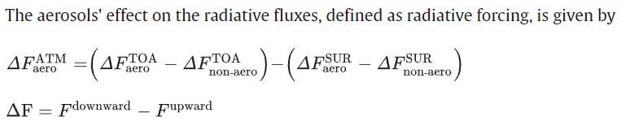

Also, shows graphically and in tables the ARF when AOD and SSA varies.

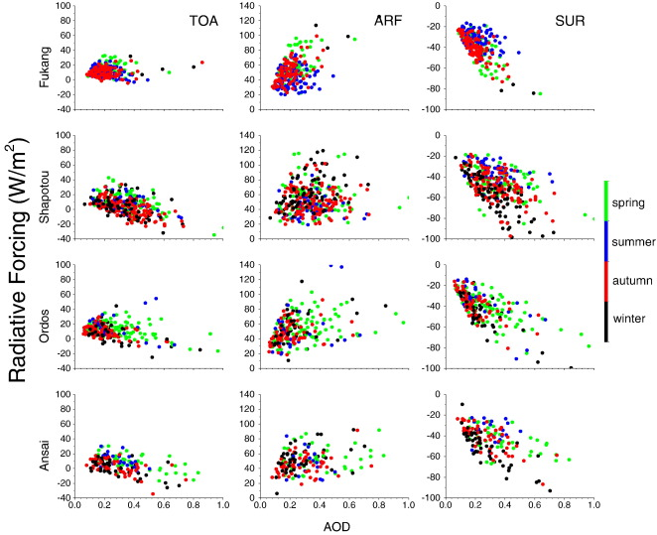

#### Aerosol optical properties and its direct radiative forcing over Tibetan Plateau from 2006 to 2017.

DOI: 10.1016/j.partic.2022.05.007

Presents the variation of SSA, Asymmetry factor, AOD, and alpha values over time.

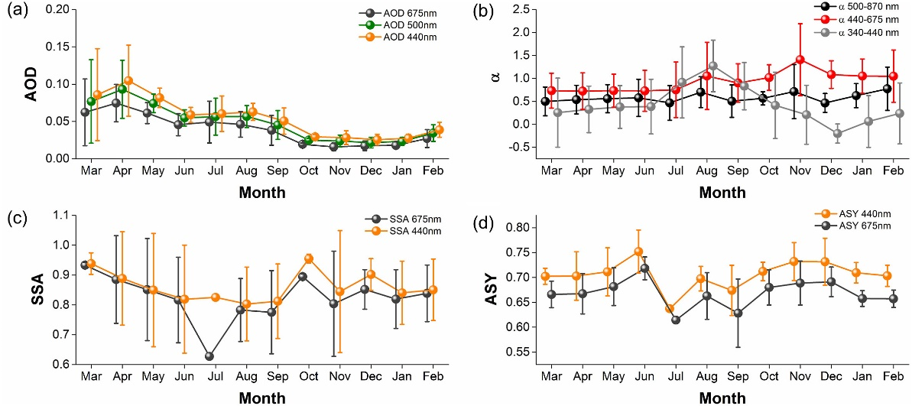

Compare the SWARF and LWARF to estimate the net ARF.

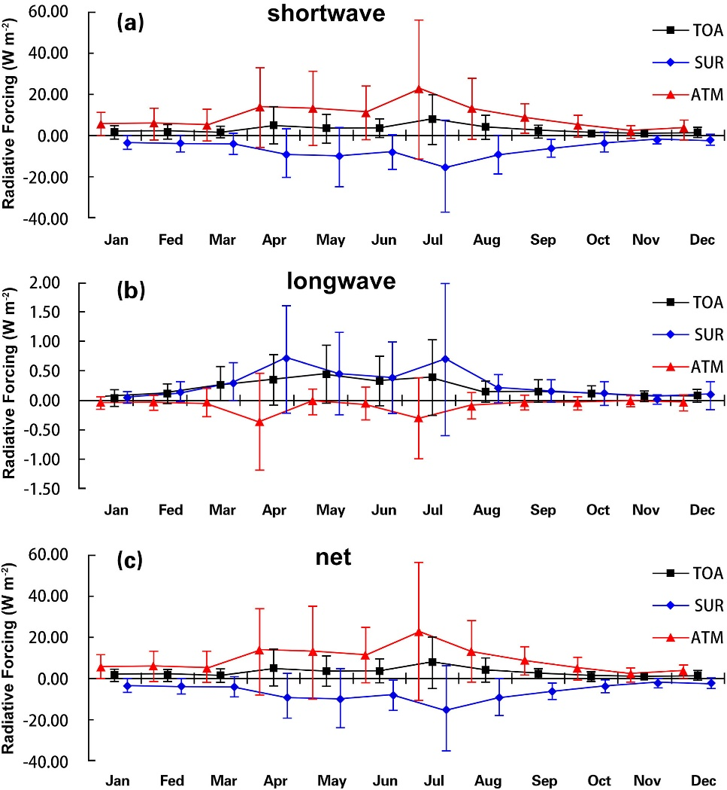

#### Aerosol optical properties and radiative effect under different weather conditions in Harbin, China.

DOI: 10.1016/j.infrared.2018.01.024

Presents the DARF and ARFE comparing with pollution (PM2.5 and PM10 concentrations) in Harbin, China.

#### Aerosol physical properties and Radiative forcing at the outflow region from the Indo-Gangetic plains during typical clear and hazy periods of wintertime.

DOI: 10.1029/2007GL031224

Compares the AOD spectra in clear sky days and hazy sky days.

Also, shows typical mean vertical aerosol backscatter intensity profile during a clear and hazy day. (lidar)

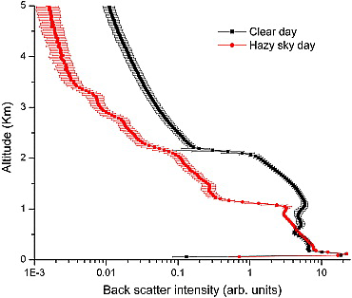

And shows the aerosol radiative forcing in clear sky days and hazy days.

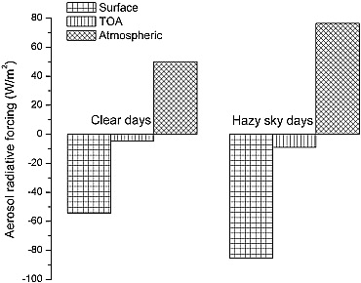

#### Aerosol Radiative Forcing Estimation over a Remote High-altitude Location (~4900 masl) near Yala Glacier, Nepal.

DOI: 10.4209/aaqr.2018.09.0342

Shows results of ARF for different reflectance surfaces.

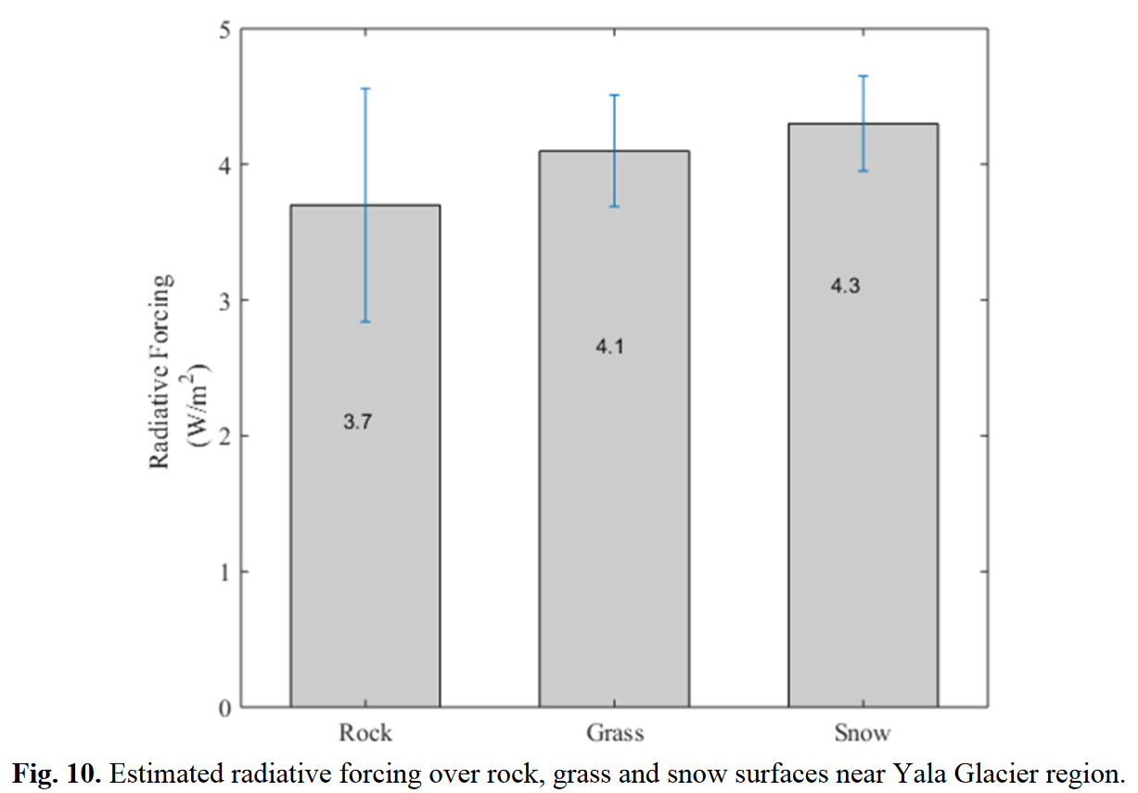

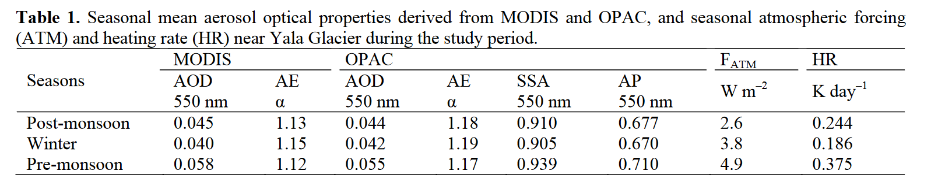

#### Assessment of Aerosol Radiative Forcing with 1-D Radiative Transfer Modeling in the U. S. South-East.

DOI: 10.3390/atmos9070271

Considers the microphysical properties of aerosols using Mie model in order to run SBDART model.

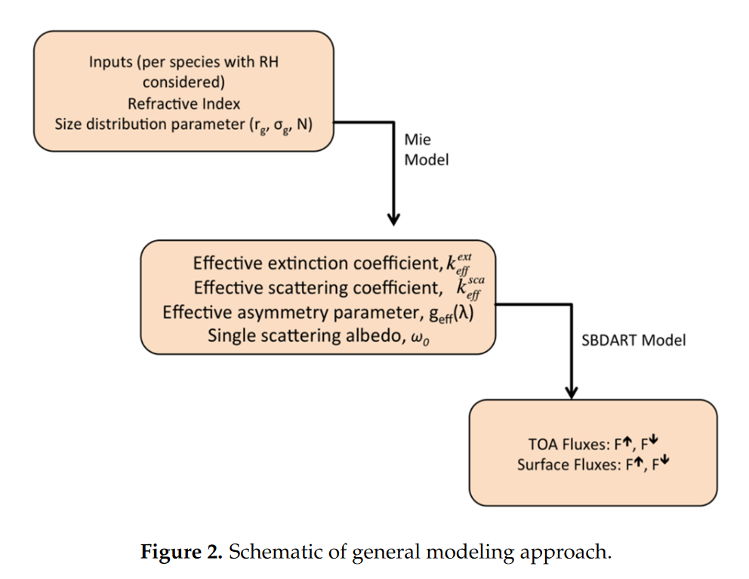

Also, shows the initialization model for each case in SBDART.

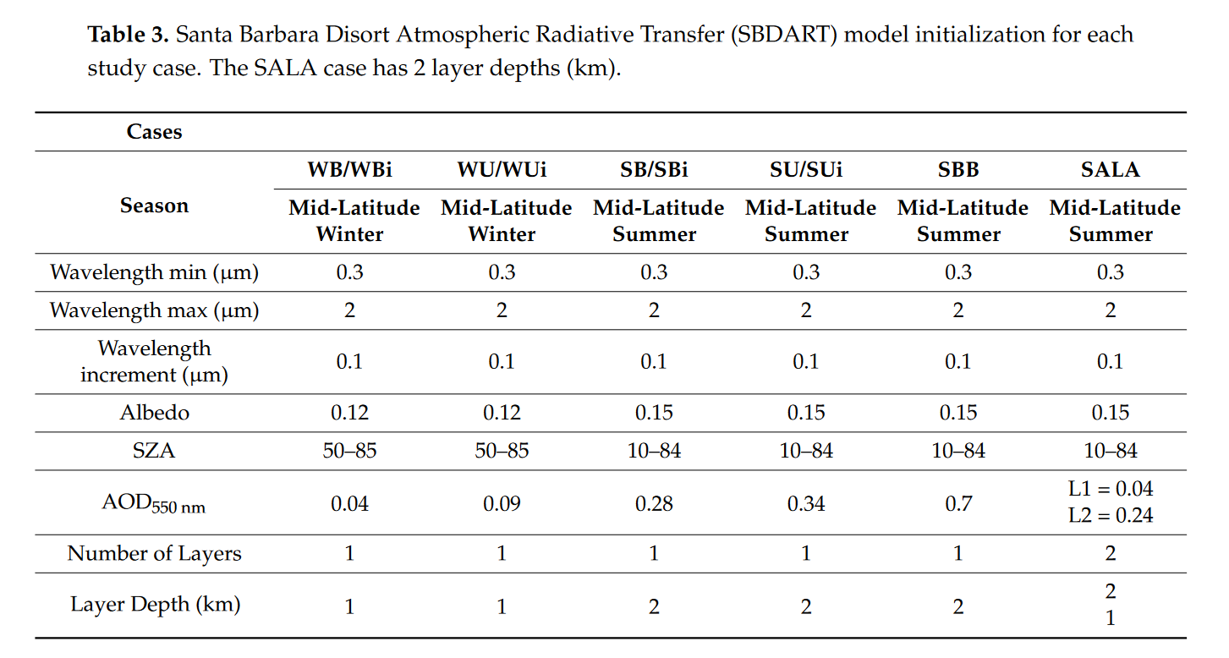

#### Bounding Global Aerosol Radiative Forcing of Climate Change.

DOI: 10.1029/2019RG000660

Presents concepts and mathematical descriptions for understanding aerosol radiative forcing effects on climate change.

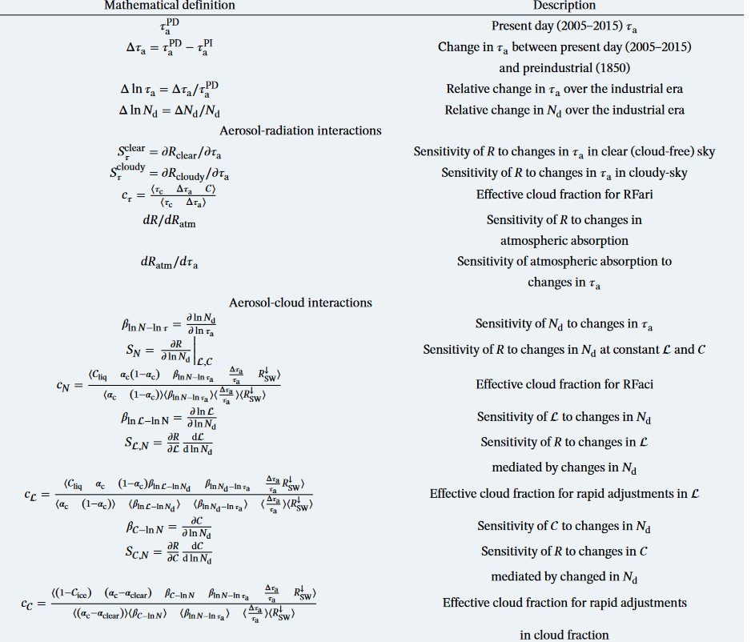

#### Climatological analysis of the optical properties of aerosols and their direct radiative forcing in the Middle East.

DOI: 10.1016/j.jastp.2019.01.002

The high correlation coefficient between the AERONET ARF and SBDART ARF shows the accuracy of the SBDART model in this study.

#### Comparison of methods to estimate aerosol effective radiative forcings in climate models.

DOI: 10.5194/acp-23-8879-2023

Not SBDART but presents a way to compare the results once the research question is answered. Also, define the semidirect effect of aerosol radiative forcing.

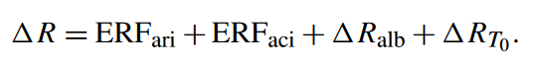



#### Estimation of Aerosol Characteristics and Radiative Forcing during Dust Events over Dehradun.

DOI: 10.4209/aaqr.2015.02.0077

Shows the impact when varying fine – coarse aerosols.

#### Estimation of Aerosol Radiative Forcing Over an Urban Environment Using Radiative Transfer Model.

DOI: 10.1109/InGARSS48198.2020.9358932

Shows the input for the SBDART model.

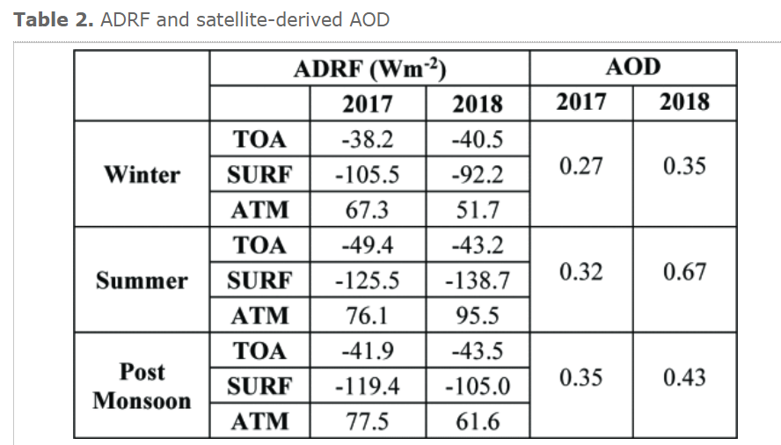

#### First observation-based estimates of cloud-free aerosol radiative forcing across China.

DOI: 10.1029/2009JD013306

A sensitivity study was performed to determine the error in ARF incurred by an error in each of the input parameters for SBDART.

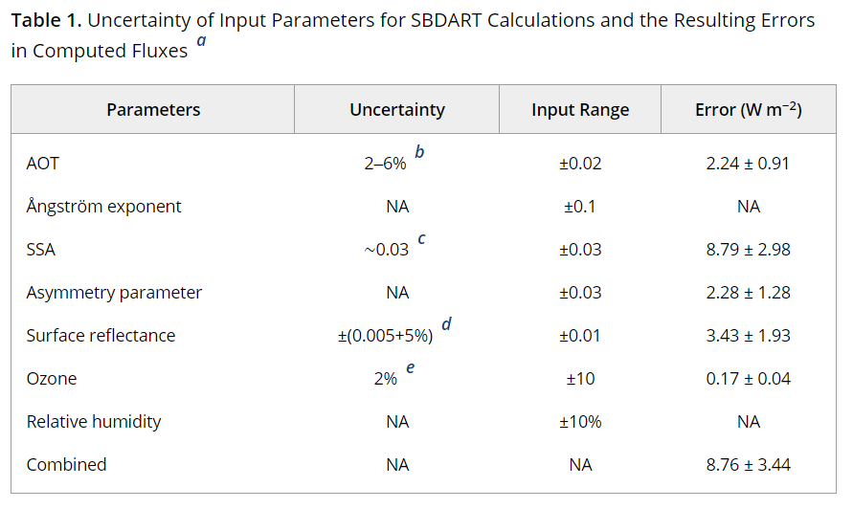

#### Grid-cell Aerosol Direct Shortwave Radiative Forcing Calculated Using the SBDART Model with MODIS and AERONET Observations: An Application in Winter and Summer in Eastern China.

DOI: 10.1007/s00376-017-6226-z

Presents first estimations of cloud-free aerosol radiative forcing using MODIS and AERONET data.

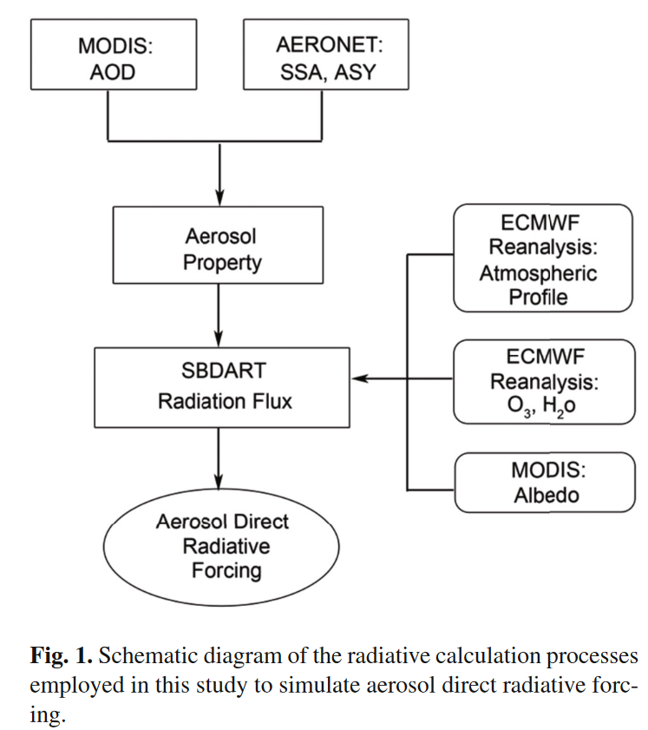

#### Long-term variations in aerosol optical properties, types, and radiative forcing in the Sichuan Basin, Southwest China.

DOI: 10.1016/j.scitotenv.2021.151490

Presents ARF describing vertical aerosol profiles.

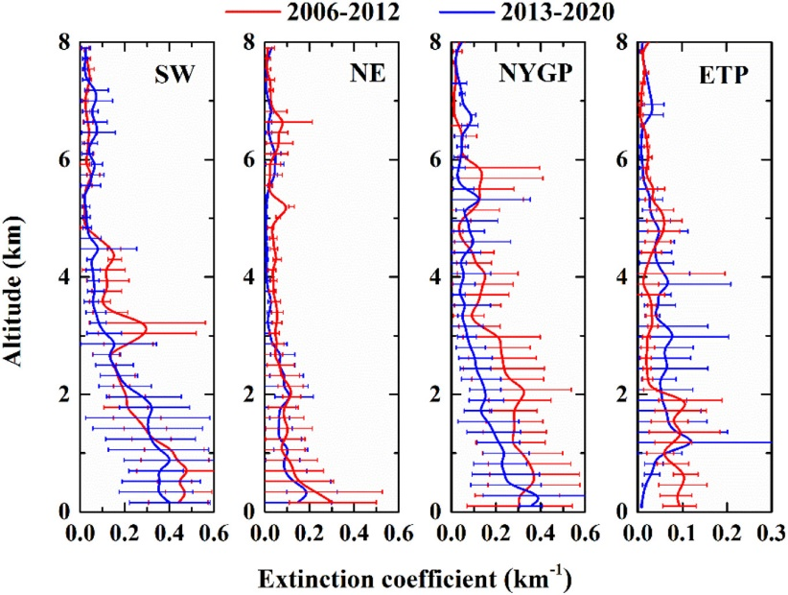

#### Monthly and seasonal variations of aerosol optical properties and direct radiative forcing over Zanjan, Iran.

DOI: 10.1016/j.jastp.2017.09.006

Aerosol volume size distribution.

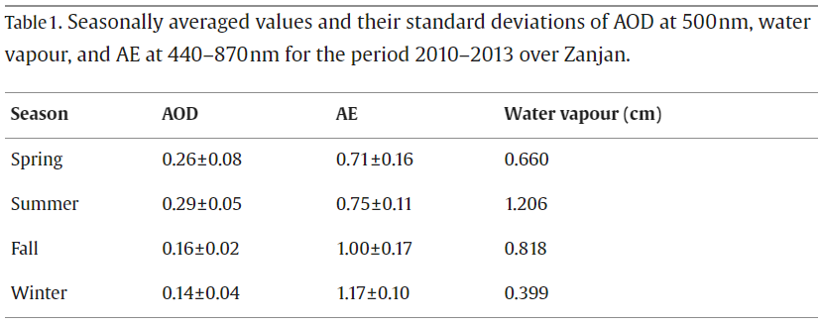

#### Quantification of Aerosol Particle Radiative Forcing Under Cloud‑Free Condition During Dry Season Period Over West Africa.

DOI: 10.1007/s41810-023-00202-8

Radiative forcing of aerosols is a major function of the aerosol SSA, AF, AOD and AE.

#### Retrieval of gridded aerosol direct radiative forcing based on multiplatform datasets.

DOI: 10.5194/amt-13-575-2020

The input of aerosol parameters has a very minor effect on the accuracy of irradiance simulation when using spectrally averaged values compared with detailed spectral information.

#### Sensitivity and uncertainties assessment in radiative forcing due to aerosol optical properties in diverse locations in China.

DOI: 10.1016/j.scitotenv.2022.160447

The maximum SSA, with an average anomaly of 0.021, because of the increase in hygroscopicity and the generation of secondary particles, which strengthens the scattering effect of aerosols.

#### Study on aerosol optical properties and radiative effect in cloudy weather in the Guangzhou region.

DOI: 10.1016/j.scitotenv.2016.05.156

Uses a polarization micropulse lidar system, the lidar emits a green laser beam with the wavelength of 527 nm; its minimum vertical resolution and maximum detection height were 15 m and 60 km, respectively. Shows the inversion of extinction coefficient by lidar and inversion of cloudy optical thinkness.

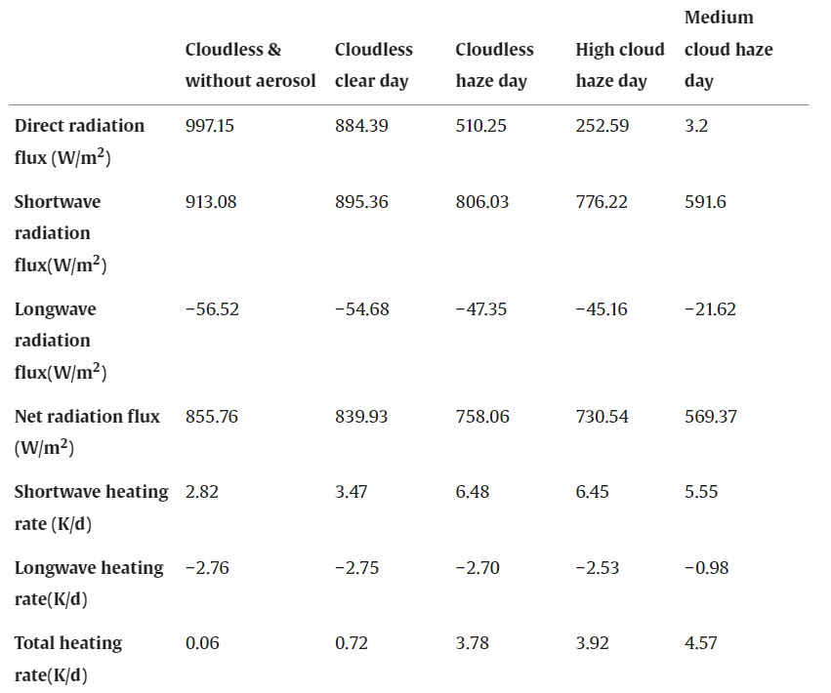

## Solar and thermal radiative effects during the 2011 extreme desert dust episode over Portugal.

DOI: 10.1016/j.atmosenv.2016.10.037

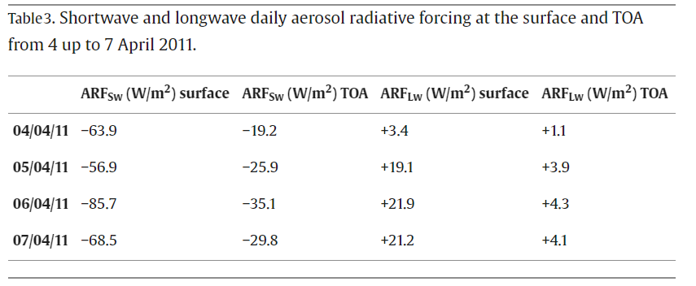

[1] Y. Dahima, T. Turakhia, A. Chhabra, and R. Iyer, “Estimation of Aerosol Radiative Forcing Over an Urban Environment Using Radiative Transfer Model,” in *2020 IEEE India Geoscience and Remote Sensing Symposium (InGARSS)*, Ahmedabad, India: IEEE, Dec. 2020, pp. 185–188. doi: 10.1109/InGARSS48198.2020.9358932.

[2] P. N. Patel and R. Kumar, “Estimation of Aerosol Characteristics and Radiative Forcing during Dust Events over Dehradun,” *Aerosol Air Qual. Res.*, vol. 15, no. 5, pp. 2082–2093, 2015, doi: 10.4209/aaqr.2015.02.0077.